What is History?
History is the written record of past events, the story of the people on our planet. It is the human story. The story of everything that people have ever done since the beginning of time. That's some story!
It is the story of changing human beliefs, triumphs and creativity. It’s the story of invention, ideas and courageous leaps forward. It’s the story of survival, conflicts and the struggle for power. It’s the story of us.

Why is History Important?
Before you study something, it is always a good idea to think about why it is important.
The Greek historian Herodotus once said, “Those who do not study history are condemned to repeat it.” This means that by understanding the past we can learn valuable lessons. We can avoid making the mistakes that caused people before us to suffer, and we can also copy their good ideas and use them to make our lives better today.
Another reason history is important is just that it is great fun and sometimes very exciting. It's like being a time-detective, hunting through the records and lost artifacts, looking for clues that might help build up a picture of what happened long ago.
History is also important for us to study because it is our story. By understanding our past and where we came from we hope to better understand where we are now and even decide about what might happen in the future.
The way things are now is a consequence of the things that happened in the past. The way things will be tomorrow will be a consequence of the way things are now.
To understand all this, it is very important that we study history.
History is the richest of all stories that can be told as it is the story of all people, in all places, at all times. It is a beautiful story. It can be a sad and shocking story, too. But it is the most exciting story there is because we can decide what will happen in the next chapter!
Reflection: Use the article above to help you answer the following questions. Use complete sentences and proper grammar. Highlight text based evidence supporting your answers.
- According to the article, what is history?

- What did the Greek historian Herodotus think about why people should study history? Which reason given in the article is the most important reason to study history?

Who Studies History?

History is very important, but it can also be very challenging to do! It takes a team of experts working together to tell the story about the past. Each member of the historical team contributes in their own unique way to discover the truth about our past.

An Archaeologist studies the past by looking at what people left behind. They dig in the earth looking for places where people once lived. They often find artifacts, or objects made by people. Common artifacts could include tools, weapons, pottery, jewelry and buildings. Archaeologists study these artifacts to learn what life was like in the past.

A Paleontologist, like archaeologists, also dig in the earth to learn about the past. However, they are interested in finding the remains or imprints of plant and animal life preserved from a long time ago. We call these fossils. Paleontologists study fossils to understand more about the animals and plants of our ancient past.

Not all remains that are found in historical digs belong to plants and animals. Sometimes human remains are found too! When this happens, the historical team turns to the “people expert” of their group – the Anthropologist. Anthropologists study human culture and remains, looking for clues about how people lived, what they valued and what they believed.

In the end, after all of the artifacts and fossil evidence has been collected, it is the historian who actually writes the record of what happened in the past. Historians are the great story tellers of the team, using the evidence provided by the other members to make an argument for what actually happened in the past. Historians do not always agree on all of the details of our history, and that is why it is important for them to use good evidence to support their version of the story!
Vocabulary: Define the following vocabulary words using the article above.
archaeologist –

artifacts –

paleontologist –

fossils –

anthropologist –

Reflection: Use the article e to help you answer the following questions. Use complete sentences and proper grammar. Highlight text based evidence supporting your answers.
- According to the article, what is the job of an historian? Why is it important for them to use good evidence?

- Which of the four professions in the article seem most interesting to you? Why?

How do We Study History?
Doing history is much like solving a puzzle. Historians study the past by gathering many “pieces” of evidence to write the story of what happened. These pieces of evidence can be either primary sources or secondary sources.
Primary sources are writings, documents and artifacts that actually come from the people and the time that the historian wants to find out about. They are first-hand pieces of evidence from the people that were actually a part of that moment in history. For example, a letter written by a Confederate soldier during the Civil War would be a primary source for that war. A video taken as the planes crashed into the World Trade center on 9/11 or an interview with Steph Curry after winning the NBA championship could all be primary sources.
Each primary source is like a single piece of a puzzle. By themselves, they only tell us a small but accurate part of the larger story! So, how do historians see the bigger picture?
Secondary sources, such as history books, biographies and most websites are sources created after an event has happened by people who were not a part of them. Secondary sources of information can be helpful, because they put together many primary sources of information tell the whole story of what happened. Secondary sources are created by putting the different “puzzle pieces” from the past together to see the bigger picture of what happened.
Primary sources and secondary sources are useful in their own way, and together, the help us understand the truth about the past!
Reflection: Use the article to help you answer the following questions. Use complete sentences and proper grammar. Highlight text based evidence supporting your answers.

- What is a primary source?

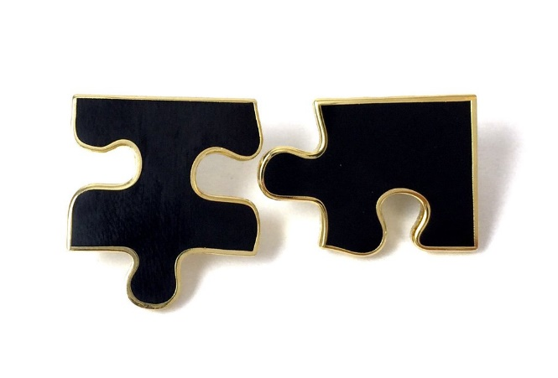

- What is a secondary source?

- How are primary sources like pieces of a puzzle?

