**Mr. Rousseau**

**World History**

**Periods 1-3**

**Week 8 Packet: The Roman Republic**

C:\Documents and Settings\rousseaum\Local Settings\Temporary Internet Files\Content.IE5\DM5QT18L\MC900036334[1].wmfC:\Documents and Settings\rousseaum\Local Settings\Temporary Internet Files\Content.IE5\DM5QT18L\MC900036334[1].wmfThe Roman Republic

***Directions:*** *Read the article below. Then define vocabulary words and answer the review questions in great detail. Your response should be organized in paragraph form and use complete sentences and proper grammar. Use the article below and Chapter 11-2 in your textbook to assist you in your answers.*

In 650 B.C. a group of people called the Etruscans moved south and took control of an Italian city-state called Rome and most of Northern Italy. The Etruscans ruled Rome for more than 100 years. Under the Etruscans, Rome became wealthy and powerful. However, the ruling family, called the **Tarquins**, grew more and more cruel. Finally in 509 B.C. the Romans rebelled. They overthrew the Tarquin king and made a new government called a **republic**. A republic is a form of government citizens vote on who their leaders will be. In a republic, citizens have the power. The rise of the Roman Republic marked the beginning of a new chapter in Rome’s history.

Early Romans were divided into two classes: patricians and plebeians. The **patricians** were wealthy landowners. These nobles made up Rome’s ruling class. Most of Rome’s people, however, were **plebeians**. This group included artisans, shopkeepers, and owners of small farms. Both patrician and plebeian men were Roman citizens. They had the right to vote and the responsibility to pay taxes and serve in the army. However, plebeians had a lower social status. Marriage between members of the two classes was forbidden. Plebeians also lacked an important political right: they could not hold public office. Only patricians could serve in government.

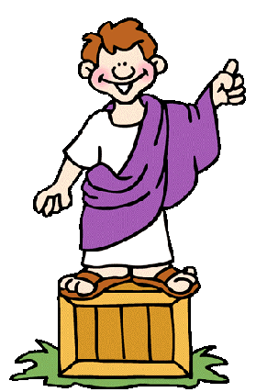**Three Branches of Roman Government**

In the Roman Republic, the top government officials in the *executive* branch were the **consuls**. Two consuls – both of whom were patricians – were chosen every year. They headed the army and ran the government. Because they served such short terms, there was little risk that they would abuse their power. The consuls also kept each other in line because each could **veto**, or reject, the other’s decisions. The word “*veto*” is Latin for “I forbid.”

Rome had other important officials called **praetors**. They represented the *judicial* arm of the Republic. Their main job was to interpret the law and act as judges in court cases. Various other officials performed other specialized duties such as keeping tax records, handling public finances, supervising public festivals and so forth.

Rome’s most important *legislative*, or lawmaking, body was the **Senate**. This was a select group of 300 patrician men who served for life. In the beginning, the Senate only gave advice to the consuls. Over time, the power of the Senate grew. By the 200’s B.C., it could also propose laws, hold debates on important issues and approve building programs.

1. *Define the following terms:*
   1. **republic** –
   2. **patricians** –
   3. **plebeians** –
   4. **consuls** –
   5. **veto** –
   6. **senate –**

**Plebeians Find A Voice**

As you might expect, plebeians complained about having so little power in the Roman Republic. After all, they fought alongside patricians in the army, and their tax payments helped the republic thrive. It seemed reasonable to the plebeians that they should have equal rights. Eventually, the plebeians took action to bring about change. In 494 B.C. many plebeians went on **strike**. They refused to serve in the army or to work in their shops or farms. They also left the city to start a republic of their own. These actions frightened patricians into agreeing to share power.

In 471 B.C. the plebeians were allowed to set up their own body of representatives called the **Council of Plebs**. The assembly elected **tribunes** who brought plebeian concerns to the government’s attention. The tribunes also won the right to veto government decisions. In 455 B.C. patricians and plebeians were allowed to marry and by the 300’s B.C. plebeians were allowed to become consuls.

The most far-reaching political reform came in 287 B.C. In that year, the Council of Plebs finally gained the power to pass laws for all Romans. Now, all male citizens had equal political standing, at least in theory. In practice, a few wealthy patrician families still held most of the power, and women remained without a voice in government. The Roman republic had become more representative, but it was far from a full-fledged democracy.

**Unusual Power**

An unusual feature of the Roman Republic was the office of **dictator**. We define a dictator today as an oppressive ruler with complete control over the state. Roman dictators also had complete control, but they served the people and ruled on a temporary basis during emergencies. As soon as the danger had passed, Roman dictators gave up their power.

The best known early Roman dictator is **Cincinnatus**. About 460 B.C. a powerful enemy had surrounded a Roman army. Officials decided that the crisis called for a dictator and that Cincinnatus was the man for the job. When the horseback rider came to Cincinnatus to deliver the news of his new powers, Cincinnatus was found on his farm, plowing his fields. A loyal and devoted citizen, Cincinnatus left his farm and gathered an army. He defeated the enemy in short order and returned to Rome in triumph. Although he probably could have continued ruling, Cincinnatus did not want power. Having done his duty, he returned to his farm a mere 16 days after becoming dictator. Some years later Cincinnatus would again be called upon by Rome to serve a second time as dictator, and again Cincinnatus would give his ultimate power back to the people once Rome’s enemies had been vanquished.

Because of his example of outstanding leadership, lack of personal ambition and service to the greater good, Cincinnatus was widely admired in his own time and in later ages. George Washington, for one, took inspiration from his example. Like Cincinnatus, Washington was a farmer when he was asked to head an army: the Continental Army in the Revolutionary War. After leading the Americans to victory, Washington returned to his plantation home. Only later, with some reluctance, did he agree to become the first president of the United States.

**Rule of Law**

One of Rome’s chief gifts to the world was its system of law. The legal system of the United States owes much to the Roman system. Rome’s first code of laws was the **Twelve Tables**, adopted around 451B.C. Before this time, Rome’s laws were not written down. As a result, plebeians claimed the patrician judges often favored their own class. They demanded that the laws be put in writing for everyone to see.

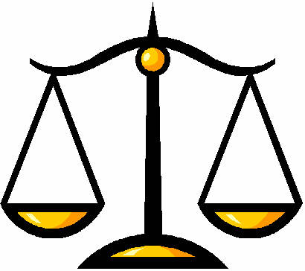The patricians finally agreed. They had the laws carved on bronze tablets that were placed in Rome’s marketplace, or the Forum. The Twelve Tables became the basis for all future Roman laws. They established the principle that all free citizens had the right to be treated equally by the legal system.

The Twelve Tables, however, only applied to Roman citizens. As the Romans took over more lands, they realized that new rules were needed to solve legal disputes between citizens and noncitizens. They created a collection of laws called the **Law of Nations**. It stated principles of justice that applied to all people everywhere. These standards of justice include ideas we still accept today. For example, a person was considered innocent until proven guilty. Also, people accused of crimes could defend themselves before a judge and judges had to look at evidence carefully before making a decision.

The idea that the law should apply to everyone equally and that all people should be treated the same way by the legal system is called the “**rule of law**”. In the age of Rome, the rule of law was still a new idea. In many lands, people at the top of society often had special privileges and did not have to obey the same laws or use the same courts as people lower down on the social hierarchy. In some places we have discussed previously people at the bottom of society did not have any legal rights at all. The rule of law is one of the key ideas the Romans gave to the world and is the basis for our legal system today.

___________________________________________________________________________________________

1. *Define the following terms:*
   1. **strike** -
   2. **tribunes** -
   3. **dictator** -
   4. **Law of Nations** -
   5. **rule of law** –
2. *Watch this video on the branches of the United States Government:* <https://www.youtube.com/watch?v=HuFR5XBYLfU> Then, *based on the reading above, compare and contrast the United States’ government with the Roman Republic. Consider things such as what kind of government each had before their republic, why each of them rebelled against their leaders, the similarities in their different branches of government and the responsibilities these different branches had.*
3. *The Romans were one of the first civilizations to practice “rule of law”, applying the law fairly to all people regardless of who they were. Why is this legacy of Roman law so important? Be sure to give details and examples to illustrate your argument below.*