Mr. Rousseau
World History
Periods 1-3

Week 3 Packet: Ancient India

Title: Ancient India – Chapter 9 – 1 Guided Notes
Directions: Read Chapter 9 Lesson 1 in your textbook. As you read, fill in the blanks on the guided notes below with the appropriate information available in the text. Highlight/Underline any vocabulary words used in the notes.
Geography of India

- India and several other countries make up the ______________________ of India
  - A ______________________ is a large landmass smaller than a ________________
  - The Indian subcontinent is part of _________________
- India is separated from the rest of _______________ by rugged mountains
  - The ___________________ border India to the north
    - _____________________ is the tallest mountain in the world
- Wide fertile _______________ lie at the foot of the mountains
  - Three great rivers called the _________________, __________________, and the _______________________ flow through the region
    - Rely on rivers for ___________________, transportation and ______________
- Landforms in central and southern India are _____________________ from the north
  - The west and east ________________ are lush ____________ lands
  - The southern two-thirds of India is known as the Deccan __________________
    - A __________________ is a broad flat area of high land
- Seasonal winds called ____________________ have a large influence on India’s climate
  - During _________________ cold dry air bow from east to west
  - During _________________ warm air brings heavy rains from west to east
    - Monsoon rains bring ________________ for crops
    - Too little rain can cause a long dry period called a _________________
Indus Valley Civilization

- India’s first civilization began around the ________________ River
  - Soil was rich, grew crops of cotton, _____________, barley and beans
  - Some traded extra food and goods
    - Indus people prospered and built ______________

- Two major cities of ____________________ and _____________________________
  - Had more than _____________________ residents
  - Had dozens of __________________
    - Larger streets were ________________ with tan colored brick
  - Used oven baked _______________ to build homes
  - Engineers and builders were highly __________________
  - Most people ________________ in farming villages outside the cities
  - City residents were ________________, shopkeepers and ________________
    - Merchants traveled as far as __________________________ to trade
Aryan Migrations and Settlement
- Around 1900BC, people of the Indus Valley began to ____________________ their cities and villages
  - Severe drought lasted hundreds of years
    - Destroyed ________________ and people starved
  - Earthquakes and _________________ changed course of the Indus River
  - New people __________________ to India

- The _______________ were not a race or ethnic group
  - Part of a _______________________ (group of similar languages) known as Indo-European
  - Lived in central ________________ but migrated to other places
    - Raised ________________ for meat, milk and butter
    - Moved from place to place to find pastures and _________________
  - Were expert horse riders, hunters and fierce ___________________
    - Sometimes ___________________ nearby villages

- Moved throughout India and mixed with ______________________ of the Indus Valley people
  - Settled down and became __________________, but still raise cattle
    - Eventually saw herds as sacred (special or holy) and banned the use of _____________________ as food
  - Turned the __________________ River valley into productive farmland
    - Grew many crops such as wheat, millet and barley
    - In the _________________ farmers grew cotton, vegetables, ________________, ginger and __________________

- Aryans lived in __________________ led by a ________________ (prince)
  - Created small kingdoms
  - Fought over cattle, treasure and ____________________
- At first, they had no written _____________________
  - They settled and developed written language called ___________________
    - Recorded sales, trade and land ownership
  - Eventually wrote hymns, _______________, poems and ___________________
    - Collected into sacred texts known as the _____________________
Ancient Indian Society
- System of social classes developed
  - Four social classes in India were called __________________
    - _________________ were priests and the most powerful
    - Kshatriyas were __________________ who ran government and army
    - ______________ were commoners who were usually farmers, artisans and merchants
    - Sudras were manual workers and _______________ with few rights
  - Four Varnas are divided up into thousands of _____________
    - Each group had its own strict rules of diet, marriage, and social customs
  - Varna system is called a _________________ system
    - People remain in the same caste or social group for _____________
  - Lowest level of society were the _______________________ or Pariahs
    - Not part of Varna system
    - Did things varnas would not do: collecting ____________, skinning animals and carrying _______________________

- ___________________ center of Aryan life
  - Grandparents, parents and ___________________ lived together
  - Elder family members were ____________________
  - Oldest _______________ was in charge of household
  - Men had more ___________________ than women
  - Boys had a __________________ (teacher)
  - Parents arranged marriages for their children
    - Married as teenagers
    - Not allowed to ____________________
Short Answer
- Although the monsoons may bring severe storms, they are considered necessary in India. Why?
_________________________________________________________________________
_________________________________________________________________________
_________________________________________________________________________
- What are the four major social groups in the varna/caste system?
_________________________________________________________________________
_________________________________________________________________________
_________________________________________________________________________
Ancient India: Chapter 9 Lesson 1 Vocabulary
Directions: Using your 9-1 Guided Notes and your textbook, write down the definition for each vocabulary word below. Then create a sentence or draw a picture in the second column that appropriately uses the word. The sentence should provide enough information to give the reader a clear idea of what that word means.
Vocabulary Word | Definition of Vocabulary Word | Sentence Using the Word/Picture Showing the Word
subcontinent

plateau

monsoons

migrated

language family

raja

Sanskrit

Vedas

guru

Title: Ancient India – Chapter 9 – 2 Notes
Directions: Read Chapter 9 Lesson 2 in your textbook. As you read, fill in the blanks on the guided notes below with the appropriate information available in the text. Highlight/Underline any vocabulary words used in the notes.
Origins of Hinduism
- __________________________ is one of the world’s oldest religions
  - It is the ______________ largest religion after Christianity and _________________
  - Sacred writings called the ____________________ teach key ideas of Aryan religion

- Believe in one universal spirit called ________________________
  - Every living thing has a _________________ that is part of Brahman
    - At death the soul leaves the ________________ and joins Brahman
  - Most Indians believe in many different ________________ (gods)
    - ___________________ the Creator
    - Vishnu the ____________________
    - Shiva the _____________________
  - Other gods were different ________________ of Brahman

- Hinduism believes in ___________________________ (rebirth of the soul)
  - Strive for __________________, the ultimate peace
  - Most souls must pass through many _________________ before reuniting with Brahman
  - Closely related to idea of _______________
    - What people do in this life decides how they are reborn
    - People who lead a _____________ life are reborn into a lower form
    - People who lead a _____________ life are reborn into a higher form
  - To earn a better existence, Hindus must follow their __________________ (personal duty)
    - People’s duties are different based on their place in___________________

- Hinduism shaped India’s way of life
  - People believed that all life was ___________________
  - People accepted the _________________ system
    - Believed people in a higher ________________ were superior
    - Gave ________________ to people to be reborn into a higher jati

Rise of Buddhism

- Some Indians felt ______________________ with the Hindu religion
  - Wanted a simpler, more _________________ faith
  - Developed new ideas and became religious ____________________
  - One teacher was _________________________________
    - Became known as the ___________________
    - Founded a new religion called______________________
- Buddhism is one of the major world ______________________
  - Most followers are in Southeast and East Asia
    - Only a _____________ live in India, its birthplace
- Siddhartha was born around 563 BC
  - Grew up as a _________________ near the Himalaya
  - Left to explore the kingdom
  - Was shocked at the __________________ and suffering around him
    - Saw _____________________, the sick and aged people
    - Understood life was full of ________________________
  - Journeyed to find the meaning of _______________
    - Stopped to ____________________ (think deeply)
    - Teachings became known as Buddhism
- Taught his followers The Four Noble ________________
  - Life is full of _____________________
  - People suffer because they __________________ worldly things
  - The way to end suffering is to stop _____________________ things
  - To stop desiring things, follow the ___________________________

- The Eightfold Path
  - Know and understand the _____________________________ (Right View)
  - Give up worldly things and do not ________________ others (Right Intention)
  - Tell the truth, do not ____________________ or speak badly of others (Right Speech)
  - Do not commit ___________________ acts (Right Action)
  - Do rewarding ____________________ (Right Livelihood)
  - Work for good and oppose ________________ (Right Effort)
  - Make sure your ________________ controls your senses (Right Mindfulness)
  - Practice _____________________ to see the world in a new way (Right Concentration)

- When people are free of earthly concerns, the will reach ____________________
  - Not a place but an emotional or ___________________ state
  - Feeling of perfect peace and _____________________

- Buddha placed little importance on the ____________________ system
  - People’s place in life did not depend on their varna
  - Believed in ___________________________
    - Taught people could end cycle of rebirth by following the _________________________, rather than their dharma
  - Many people accepted the ____________________ message
    - _________________________ and lower jati especially
    - All people could achieve enlightenment
  - When Buddha died his followers disagreed over the meaning the Buddha’s ______________
    - Divided into two groups: _________________________ Buddhism and ______________________________ Buddhism

- ________________________ means “teachings of the elders”
  - View Buddha as a great teacher, but not a _______________
  - Major religion of modern day _________________________
    - Spread ideas to Myanmar, Thailand, Cambodia and ________________

- _______________________ Buddhism teaches Buddha is a ________________
  - Believe the _______________________________ is too difficult for most people
  - By worshipping Buddha, people go to ___________________ when they die
    - There they can reach ____________________
  - ___________________________ hold a special place in Mahayana Buddhism
    - Enlightened people who stay and help others reach nirvana
  - Spread northward to __________________ and to Korea and ____________________
  - Special Buddhism in Asian country of _____________________
    - Leaders called ___________________ led government
    - Dalai Lama led government, Panchen Lama led the _____________________
    - Both thought to be _____________________________ of the Buddha

Jainism
- Another Indian faith known as ____________________ arose around 500BC
  - Founded by religious leader named _______________________
    - Lived in India at the same time as _______________________________
  - His followers became known as ________________
  - Taught people needed to stop _____________________ world things
    - Practiced strict ___________________

- Key value of Jainism is ______________________
  - Non-violence towards all living things
  - Idea has influenced India’s __________________ and politics
    - In 1900’s leader named ______________________________ led a non-violent struggle against British rule
    - Dr. Martin Luther King Jr. led non-violent protests to gain rights for ___________________________________
Short Answer
- What do the ideas of reincarnation and karma have in common?
_________________________________________________________________________
_________________________________________________________________________
_________________________________________________________________________

- How would practicing Buddhism affect people’s daily lives?
__________________________________________________________________________
__________________________________________________________________________
__________________________________________________________________________
__________________________________________________________________________
__________________________________________________________________________

- What do Hindus believe about Brahman?
_________________________________________________________________________
_________________________________________________________________________
_________________________________________________________________________
_________________________________________________________________________
Ancient China: Chapter 9 Lesson 2 Vocabulary

Directions: Using your 9-2 Guided Notes and your textbook, write down the definition for each vocabulary word below. Then create a sentence or draw a picture in the second column that appropriately uses the word. The sentence should provide enough information to give the reader a clear idea of what that word means.
Vocabulary Word | Definition of Vocabulary Word | Sentence Using the Word/Picture Showing the Word
Hinduism

Brahman

reincarnation

karma

dharma

Buddhism

meditate

nirvana

Jainism

Hinduism & Buddhism Quiz
Matching. Write the letter of the correct definition next to each vocabulary term.
- ________ Vedas | - Eight virtues Buddhists must master to end desire.
- ________karma | - A person’s “duty” in Hinduism.
- _______ Eightfold Path (Middle Path) | - The world’s 4th largest religion. Founded by Siddhartha Gautama.
- ________ Brahma | - The “one universal spirit” all souls want to join in Hinduism.
- ________dharma | - Collection of religious teachings sacred to Hinduism.
- ________ Vishnu | - The world’s 3rd largest religion. Found mostly in India.
 | - A dreamless sleep, a state of personal peace in Buddhism.
- ________Buddha | - Belief that actions in this life result in good or bad consequences in the next life.
- ________ reincarnation | - Belief that a person must live through many lives in a cycle of death and rebirth.
- ________ nirvana | - The Creator god in Hinduism.
- ________ Shiva
- ________Brahman  - ________Buddhism  - ________ Hinduism  - ________ meditate | - Name given to Siddhartha Gautama which means, “wise one”.  - The Destroyer god in Hinduism.  - To concentrate on a single idea. Important in both Buddhism and Hinduism.  - The Preserver god in Hinduism.

Short Answer. One of the most important teachings of Buddhism is the Four Noble Truths. Complete the Four Nobles Truths below by filling in the word that is missing from the blank.
- Life is __________________________.
- Suffering is caused by _________________________.
- To end _______________________ on must end _______________________.
- End desire by following the ____________________________________.

Short Answer. Below is a social pyramid representing the Indian Caste (Varna) System. Complete the social pyramid by filling in the box below with the names of each of the five castes.

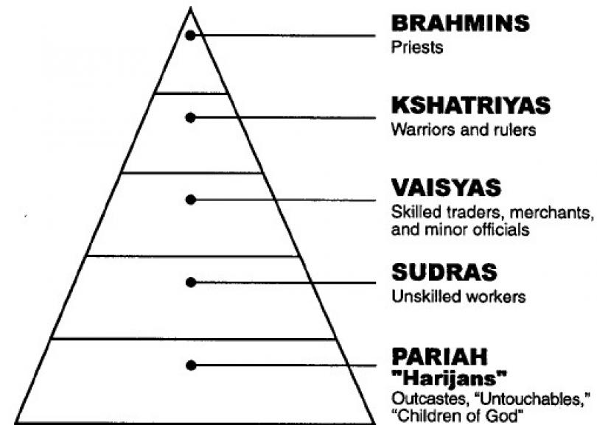
KSHATRIYAS
SUDRAS

PARIAHS
BRAHMIN
VAISYAS

