ELEMENT 1 – LOCATION
Everything on our planet has a location! Geographers use two different ways of finding location on Earth. One way is relative location. People can find relative location by using objects near a place to describe where it is. For example, if you were trying to describe the relative location of Swift Creek Middle School, you might say, “Swift Creek is between the Alford Greenway and Buck Lake Elementary School”. People use relative location all of the time to find where they are going.
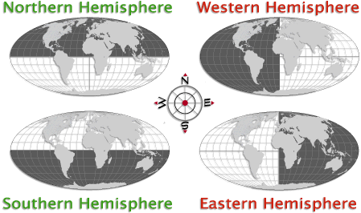
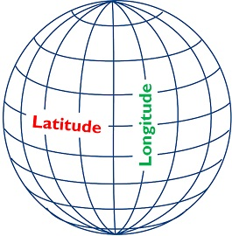
Another way that geographers find location is by using absolute location. Absolute location is more accurate than relative location, because it uses special lines called latitude and longitude to find an exact location on the Earth! Latitude lines circle the earth sideways (East/West) and measure distance North and South of the middle latitude line, the equator. Longitude lines circle the earth up and down (North/South) and measure distance from the middle longitude line, the prime meridian. The equator and the prime meridian divide the earth into equal halves called hemispheres. Whenever a latitude and longitude line meet on the earth, they create the absolute location of that place. Geographers write this down as a set of coordinates, which can tell boats, planes and cellphones the absolute location of any place on the planet!

VOCABULARY
Directions: Using the article above, write down the definition for each vocabulary word below. Then create a sentence or draw a picture in the second column that appropriately uses the word. The sentence should provide enough information to give the reader a clear idea of what that word means.
Vocabulary Word | Definition of Vocabulary Word | Sentence Using the Word/Picture Showing the Word
relative location

absolute location

latitude

longitude

equator

Prime Meridian

hemisphere

coordinates

