ELEMENT 1 – LOCATION
Everything on our planet has a location! Geographers use two different ways of finding location on Earth. One way is relative location. People can find relative location by using objects near a place to describe where it is. For example, if you were trying to describe the relative location of Swift Creek Middle School, you might say, “Swift Creek is between the Alford Greenway and Buck Lake Elementary School”. People use relative location all of the time to find where they are going.
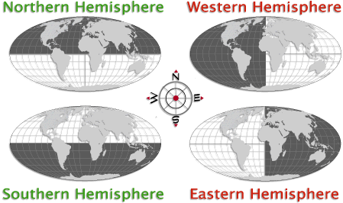
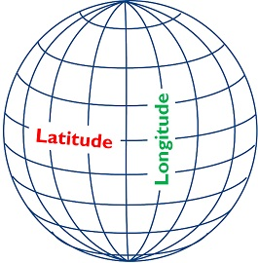
Another way that geographers find location is by using absolute location. Absolute location is more accurate than relative location, because it uses special lines called latitude and longitude to find an exact location on the Earth! Latitude lines circle the earth sideways (East/West) and measure distance North and South of the middle latitude line, the equator. Longitude lines circle the earth up and down (North/South) and measure distance from the middle longitude line, the prime meridian. The equator and the prime meridian divide the earth into equal halves called hemispheres. Whenever a latitude and longitude line meet on the earth, they create the absolute location of that place. Geographers write this down as a set of coordinates, which can tell boats, planes and cellphones the absolute location of any place on the planet!
relative location –
absolute location –
latitude –
longitude –
Equator –
Prime Meridian –
hemispheres –
coordinates –
ELEMENT 2 – PLACES & REGIONS
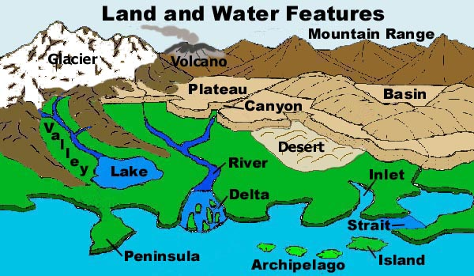
Any specific location on the Earth is called a place. Places are described by their physical characteristics and their human characteristics. Physical characteristics are any natural feature found in a place. Plants, animals, landforms (natural features of the Earth’s surface such as mountains, islands etc.), bodies of water and climate (pattern of weather over a long period of time) are all examples of physical characteristics. For example, a physical characteristic of Tallahassee are its beautiful dogwood trees and rolling hills.
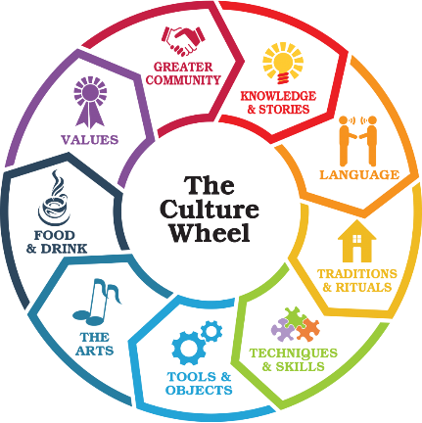
Human characteristics are any man made objects or cultural traits of a place. This could be objects like cars, buildings or toys. Human characteristics are also things that describe the people of a place, such as their race, religion or the language that they speak. They could even be things that affect the way people live in a place, such as their food, music, clothing or traditions. For example, some human characteristics of New York City are the Empire State building, Broadway plays and New York hot dogs.
Some places have characteristics in common with each other. Geographers sometimes group places together based on the characteristics they have in common. These groups are called regions. The South-Western United States is a desert region, that includes many different states such as Arizona, New Mexico, Nevada and parts of California.

physical characteristics –

landforms –

climate –

human characteristics –

regions –
ELEMENT 3 – PHYSICAL SYSTEMS
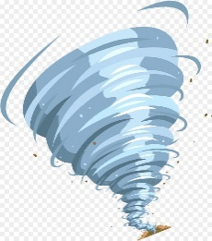
Have you ever experienced a terrible storm or some other natural disaster? Powerful forces of nature called physical systems are constantly shaping the world around us. Some physical systems are destructive and dangerous, such as hurricanes, tornados, floods and wildfires.
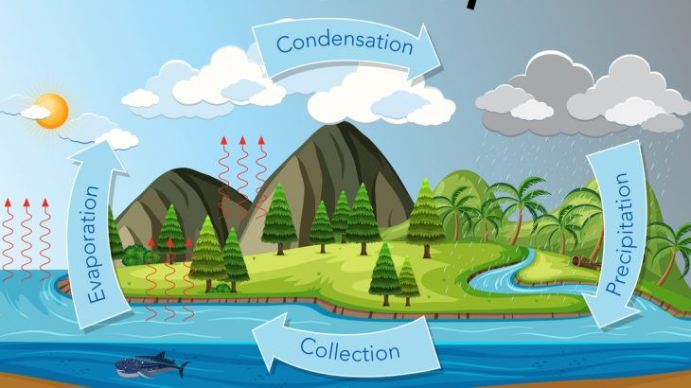
Other physical systems are less noticeable, but still play a large role in shaping the world around us. Wind and rain cause erosion, which breaks down dirt and rocks. Tiny animals called bacteria eat dead plants and animals, giving nutrients back to the soil for plants to use as food. There are many physical systems all around us, shaping the world in amazing ways!

- What is a physical system?

- How is erosion an example of a physical system?

- Describe a physical system that you have experienced personally. How did it shape or change the world around you?

ELEMENT 4 – Human Systems
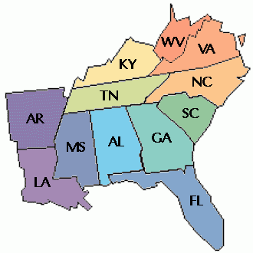
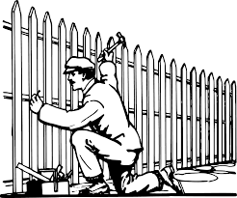
Human systems are the ways in which people are shaping and changing the world they live in. One way people do this is by creating physical boundaries and political boundaries. Physical boundaries are things like walls, fences and other man-made barriers that organize space on the earth. Political boundaries are invisible boundaries that mark who owns or controls a particular space. Some examples of political boundaries might be borders of countries or states, but they could also include things like property lines, school zones or other dividing lines.
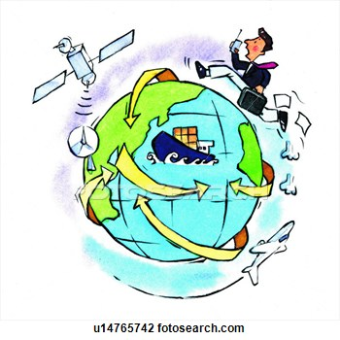
Humans not only shape the world by creating boundaries, but also by creating systems that move their goods, ideas and people around the world. Have you ever traveled to a place you’ve never been before? When you did, you brought with you your own ideas and belongings that were not there before – you changed the place you moved to! When people, goods or ideas travel around the world, they change the places that they travel to. For example, LEGOS were invented in the country of Denmark, but because that good has moved to new places through human systems, today they are a favorite toy found around the world. An airport or train station are two other great examples of human systems that move people, goods and ideas that shape the world we live in. One thing is for sure, with so many human systems, the world around us is constantly changing!
human system –

physical boundary –

Political boundary –

- How might the internet be an example of a Human System?
ELEMENT 5 – HUMANS AND THE ENVIRONMENT
We live on a beautiful and abundant planet. People use the Earth for many things: food, fuel, shelter, materials and more! Although the Earth has much to give us, our actions as people can affect our planet in big ways. Some things humans do can be harmful to the environment, while other actions can help protect and preserve our beautiful planet. Use the chart below to identify the different human activities and decide whether they have a negative or positive impact on our planet! If the activity is positive, explain the benefit it provides. If it is negative, offer up a solution to fix that environmental problem!
HUMAN ACTIVITY | Pos. | Neg. | BENEFIT/SOLUTION
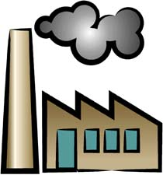
POLLUTION

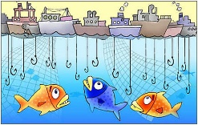
OVER
FISHING
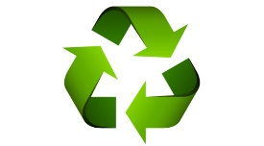

RECYLCING
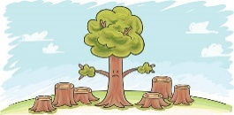
DEFORESTATION

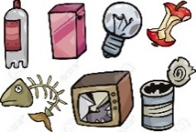
TRASH/ LITTERING
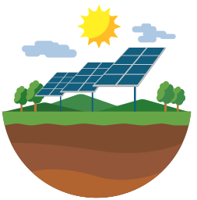
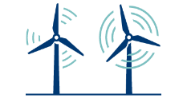

RENEWABLE ENERGY
WILDLLIFE
RESCUE

