CLIMATES OF AFRICA
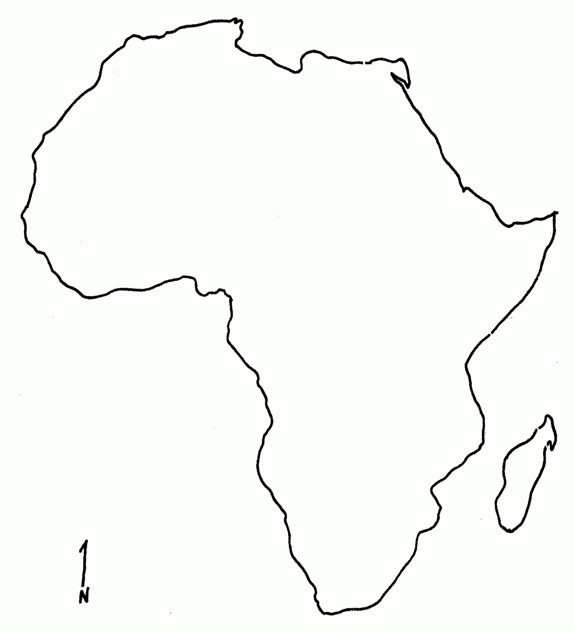

AFRICAN CLIMATES
The continent of Africa is a very unique place with many different climates. A climate is a pattern of weather in an area over a long period of time. These climates create very unique habitats for physical features such as plants, animals, landforms and of course, people!
In the very heart of Africa are the tropical rainforests. Tropical climates are hot year round with heavy amounts of rainfall. Because of these warm temperatures and plentiful rainfall, huge forests are able to grow. These forests are called rainforests due to the incredible amount of rainfall they can receive each year. Some rainforests in Africa get over 200 inches of rain in a single year – we only get 60 inches of rain here in Tallahassee! Rainforests in the tropical climate are home to many species animals and plants – in fact, over half of the world’s different plants and animals can be found in the rainforest. The tropical climate of Africa is also important because the heavy rains here feed some of Africa’s most important rivers. The Nile River, The Congo River and the Zambezi River all begin in the tropical rainforests of Africa – giving water and life to millions of Africa’s people living across this great continent.
Towards the middle of Africa the hot desert sands give way to large plains of grassland vegetation. This climate is known as a savanna, which is similar to the prairies or grasslands of the United States. Savannahs have seasonal rainfall, with part of the year receiving heavy rains and another part receiving no rain at all. Because of this, no large trees or forests can grow, but instead, tall grasses, bushes and small plants cover the ground. This makes the savanna an excellent habitat for many of Africa’s most recognizable animals. Giraffes, zebras, gazelles and water buffalo all take advantage of the large amount of food available, and this also means predators such as lions, cheetahs and leopards prowl looking for a meal of their own.
The Northern and southern coasts of Africa are home to a very unique climate called a Mediterranean climate. This climate gets its name from the Mediterranean Sea, which surrounds Africa’s northern coast. Mediterranean climates are known for their mild temperatures and predictable weather. Never extremely hot or extremely cold, this coastal climate receives most of its rain during the wintertime, and remains mostly dry during the summer. Because of its mild temperatures and predictable rainfall, Mediterranean climates are a destination for tourists worldwide!
Most of Africa is covered in deserts. A desert is a climate that receives little to no rainfall. The largest desert in Africa is the Sahara desert, the 2nd largest desert in the world. It stretches across the entire northern half of the continent, covering more land than the entire United States of America! Life in these deserts is harsh, as water is hard to come by. Thankfully in some parts of Africa’s deserts you can find an oasis, which is a fertile spot fed by water from under the ground. Just be careful when you got out in one of Africa’s deserts, as temperature these can reach over 120˚ F during the day, and massive sand storms can cause real damage when they come your way!

